EASTER FAYRE

Saturday 15th April
12:30pm – 3:30pm
Lifton Community Centre

Household Linen; Jewellery; Accessories; Shoes
Good quality Clothes at rock bottom prices
Gifts; Local interest; Craft; Bric-a-brac
Soft Toy tombola-prize every time! Children's corner
Cat-related items; Books; Jigsaws; Tombola
Plants & Garden items; Toys; Cakes & Preserves

Good Raffle
FREE Children's 'Eggciting' Easter Egg Hunt!!

Sausage rolls, hot cross buns, tea and coffee served

Admission: Donation into box at entrance please;
this helps with the cost of hiring the hall

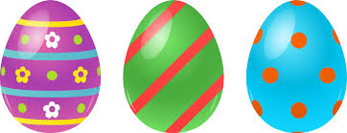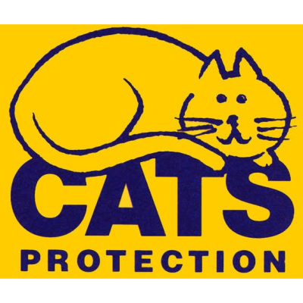

All proceeds to Launceston & District Cats Protection
(Reg. Charity 203644)

